In the low-temperature regime extruded SCR catalysts are more active than coated SCR catalysts.
Please explain: What is an extruded catalyst? What is a coated catalyst?
Extruded catalyst: The active catalyst material is extruded mixed with binders and fibers, i.e. the monolith structure is composed mainly of catalyst.
Coated catalyst: The active catalyst is coated in a thin layer on a ceramic or metallic substrate.

Why is the extruded catalyst more active than the coated one at low temperatures? What limits the reaction rate?
Since the activity of the catalyst itself is rate-limiting at low temperatures, the higher amount of SCR catalyst in an extruded catalyst results in higher activity.

Why is the activity of both catalyst types similar at higher temperatures? What limits the reaction rate?
At high temperatures the SCR reaction becomes diffusion-limited, i.e. only the outer layer of the catalyst is involved in the SCR reaction. Since the outer layer is composed of active SCR catalyst for both catalyst types, similar activity is observed.

Draw the schematic activity curves for both catalyst types over the typical SCR temperature range.
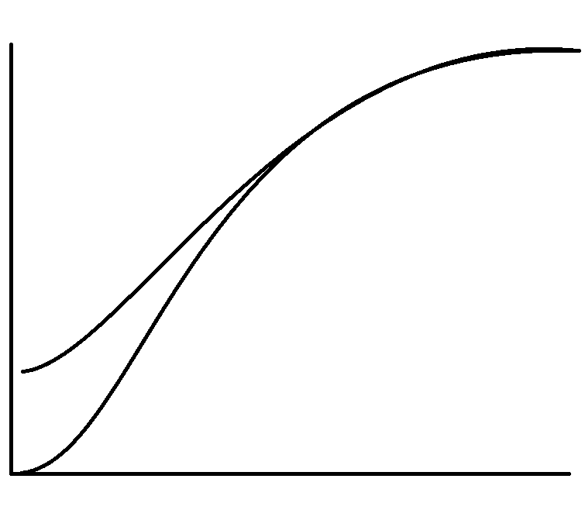
Coated catalyst
T
DeNOx
Extruded catalyst

